**Computer Application in Engineering Design**

**Lab # 01**

**Exercise:**

1. **Booking a bus ticket**

**Flow chart:**

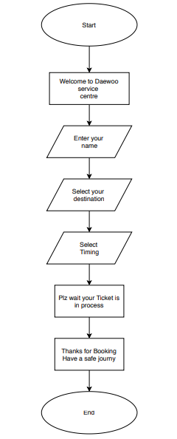

1. **Booking an airline ticket**

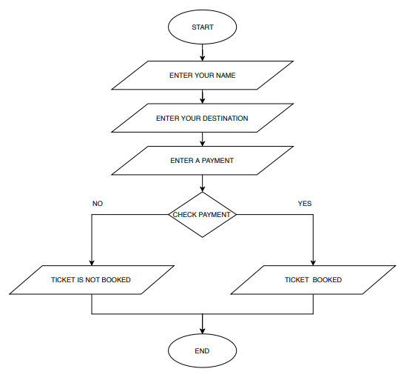**Flow Chart (online order)**

1. **Ordering a book**

**Flow chart:**

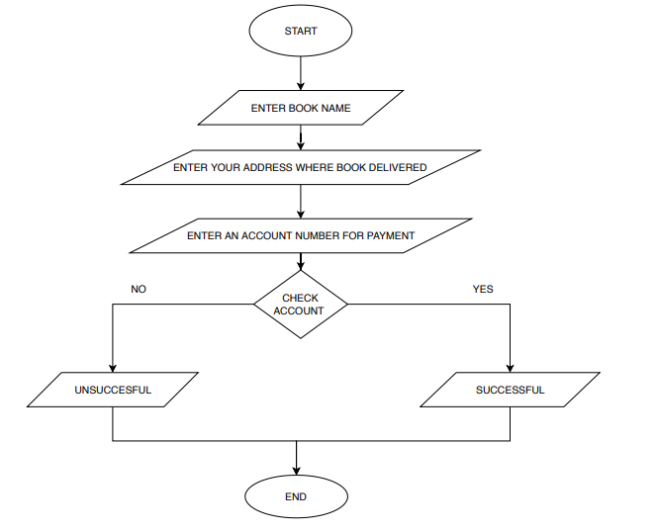

1. **Ordering a food item**

**Flow chart (online order)**

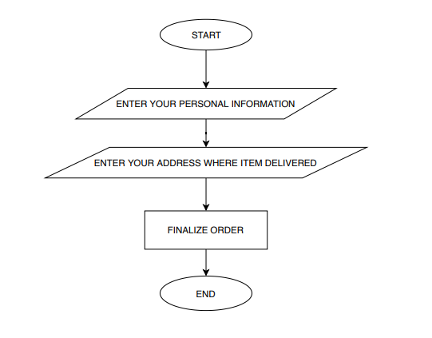

1. **Depositing money in bank**

**Flow chart:**

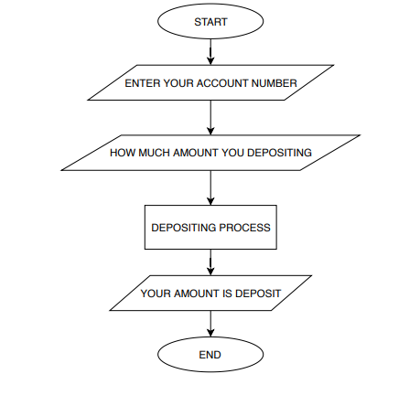

1. **Taking Cash from ATM**

**Flow chart:**

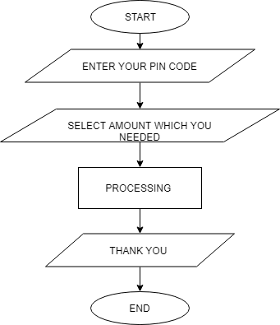

1. **Taking Cash from Bank**

**Flow chart:**

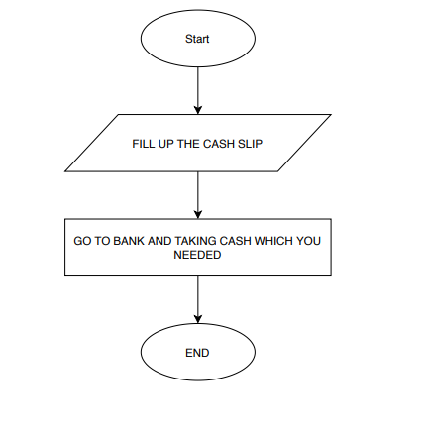

1. **Purchasing item from Mart**

**Flow chart:**

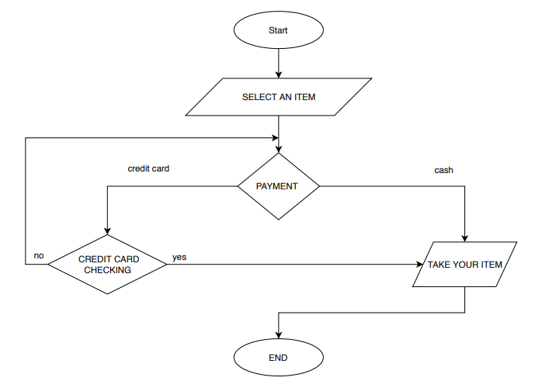

1. **Taking Admission in university**

**Flow chart:**

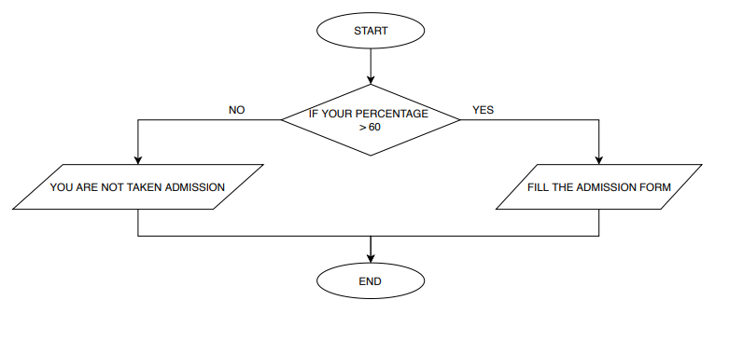

1. **Fee payment procedure in a university**

**Flow chart:**

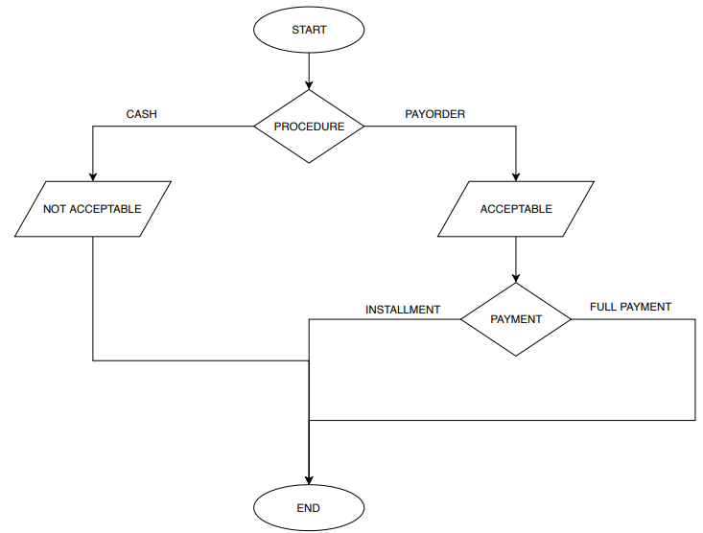

1. **Reporting a crime in police station**

**Flow chart:**

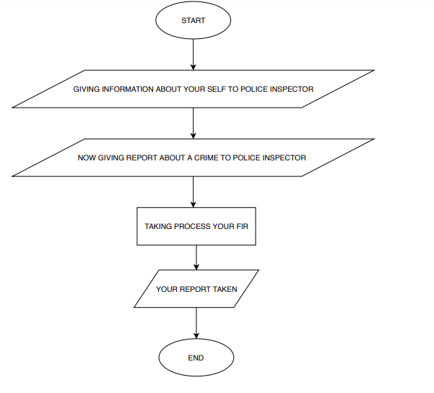

1. **Hiring a cab**

**Flow chart: (using mobile phone)**

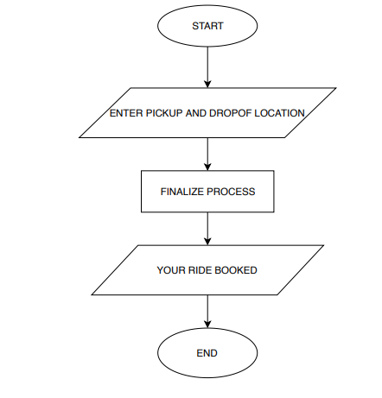

1. **Taking an apartment on rent**

**Flow chart:**

